Turkish-German University
Social Science Institute
Master of European and International Affairs

U.S Foreign Policy: Why U.S Withdrew from Iran nuclear deal
An explaining with foreign policy theories

ONUR ALP
188101020
External Policy Analysis in a Multi-Level Perspective
AVU 106
26.04.2019

TABLE OF CONTENTS
INTRODUCTION…………………………………………………………………………………3
1.) OBAMA’S ERA AND U.S FOREIGN POLICY………………….…….4

2.) TRUMP’S ERA AND U.S FOREIGN POLICY………………………..4

3.) THEORICAL APPROACHES……………………………………………….5
3.a) Balance of Threat theory………………………………………………5
3.b) Neorealism and Neoclassical realism……………………….…..6
3.c) New liberalism……………………………………………………………..8

4.) CONCLUSION…………………………………………………………………9

5.) REFERENCE LIST…………………………………………………………….9

INTRODUCTION
The Joint comprehensive plan of action ( it is known as Iran nuclear deal) was agreed upon among the Iran, permanent members of the United Nations Security Council plus Germany (P5+1) and European Union on 14 July 2015. U.S lift the some certain sanctions with respect to Nuclear activities of Iran, in exchange Iran gives up its nuclear activities and allows the experts from U.N and International Atomic Community to check the facilities in Iran.
The Disarmament experts deemed it as an achievement of the Obama administration not confronting militarily with Iran and found a solution hindering proliferation of Nuclear weapons. On the other hand, this deal was severely criticized within U.S. While it was debated in Congress, its opponents asserted three alternatives. The first is to do away with this deal that preceded it and do nothing else which in the sense, few restrains on Iran’s nuclear program (Beinahr, 2015). The second is to bomb certain plant in which uranium-enrichments take place. However, for this second one, it seems more controversial because, it could stir up wars and destroy regional stability, in addition, under this kind of circumstances, it would give a reason to carry on this nuclear program and pursue its ambition to obtain nuclear weapon (idib). The last alternative is to increase the sanctions that can harm Iran’s economy and Iran was forced to give up its nuclear program or would be ready to give some concessions (idib).
This deal was implemented despite some other critics and it lasted approximately three years. However, during the presidential election, Donald Trump called this deal incompetently negotiated and one-sided (Stokols, Grass 2015). Then he was elected, he gave the signal of abandonment. Especially President Trump and Israel Prime Minister Netanyahu claimed that Iran doesn’t abide by the deal and they are still clandestinely seek to get hold of nuclear weapons (Aljazeera 2018). As the Israel PM Netanyahu made a presentation in United Nations on first may 2018, He mention that Iranian officials were keeping tonnes of nuclear equipment and material in a warehouse, in violation of 2015 nuclear deal (idib). On 18 may 2018 U.S withdrew from Joint Comprehensive Action of Plan. Nonetheless, this decision unraveled the signature of the predecessor Obama which is seen a prominent foreign policy achievement and divided U.S and European allies (Landner 2018). In the wake of U.S withdrawal, European Union decided to stick by nuclear deal and foreign ministers from U.K, France, German and EU publish a statement on the Iran nuclear deal and demonstrating that the deal is working and delivering on its goal (Foreign and Commonwealth office, HM treasury, The Rt Hon Jeremy Hunt PM and the Rt Hon Phillip Hammond MP 2018). According to International Atomic Energy Agency, Iran complies with its part and it has not been found enrichment or other violation in this deal affirming that 12 reports shows Iran is abiding by the its commitments under JCPoA ( IAEA, 2018).
In this paper, I would like to search and discover the withdrawal process using some foreign policy theories. I will also try to answer the question ‘’ How can we explain U.S foreign policy with respect to withdrawal from nuclear deal and consequently and successively the other incidence linked to this process In doing that, First part it will be briefly mentioned signature process and Obama’s era in U.S, then Trump’s foreign policy regarding the deal. Second Part it will be approach some important foreign policy theories.
OBAMA’S ERA AND U.S FOREIGN POLICY
From the inauguration of the Obama as a new U.S President, He wanted solve some international problems and alter U.S foreign policy. The very Prominent and important example is Reset policy with Russia. Due to Georgian war and NATO enlargement rendered the bilateral relation to exacerbation. Ameliorating the relations with Russia gave the opportunity to the U.S to work with Russian to address the challenges presented by Iran regarding its nuclear program and failure to meet international obligation (Office of the press secretary). Both countries and other parties worked on taking some measure on Iran. Especially UNSCR 1929 imposed some certain restriction on its nuclear program, conventional military and ballistic program and in harmony with this new resolution, Russia declared that they won’t deliver the S-300 missile (idib). The new administration’s foreign policy in this case created softening process with Russia and deal with the countries which decides to build nuclear facility and try to get nuclear weapons which can imperil the security of the U.S and its allies.
In 2009, the disputes over Nuclear energy began because U.S reveal clandestine uranium enrichment and Iran acknowledged the claims (The Guardian, 2009). Thereupon, the sanctions were imposed on Iran. But in 2013, Rouhani who is found very pragmatic and promised to improve the economic situation in Iran, was elected (Miliani, 2013). After his inauguration, he decided to negotiate the nuclear program with western state and made a phone conversation with Obama which is the first high-level contact between both country’s leaders (Sterio, 2016). After some negotiation process, this deal was signed and both sides saw this as win-win solution (Borger, 2015). Even if there would be any domestic attempt to undermine the deal, he promised to use his veto power to implement the deal (idib). It can be said that during the Democrats were in the house, they wanted to protect this deal because it was seen very important regarding the peace and security in Middle East and foreign policy achievement left from Obama.

TRUMP’S ERA IN U.S FOREIGN POLICY
During the Presidential election in U.S, Nuclear deal were getting more controversial. Democrat party announced to safeguard the deal. On the other hand, Republicans criticized the deal, they gave the signals for withdrawal. When Trump won the election, One year later he withdrew from the deal, although the indicators demonstrated that there weren’t violation (IAEA, 2019). However Trump said ’’the agreement phases out by 2030 if allow to stand the agreement would spark a nuclear arm race in the Middle East, Everyone would want their weapons ready by the time Iran had theirs. In addition, he thinks this deal cannot prevent Iran and finds defective at its cores (Rascoe, 2018). His withdrawal raised the disturbance particularly with its European allies. High Representative of E.U declared that they would work with the international community to preserve the deal as well as declaring that it is not a bilateral deal (Nivet, 2018). Europe and the other signatory now try to save this deal despite the new U.S sanction that most damaging to the Iranian economy that targets its oil sales, its oil sales, shipping, banking, insurance industry, and so on (Marcus 2018).
FOREIGN POLICY THEORIES
Balance of Threat theory
Balance of Threat theory is a theory within Realism and this theory predicts that states will balance the threatening states (Wohlfoth, 2016:p 40). Unlike the balance of threat, to balance out is not necessary. The point here is to prevent the threat, Threat can be outnumber or exceed in power. This threat under three key variable can be determined: Aggregate capabilities ( State’s military power and economic budget etc.), Geography ( the proximity matters) and Perception of aggressive intentions (idib). Those three key variable of balance of threat theory determine the foreign policy of the countries. In this case, for U.S, there is two important issue that should cope with it: First Israel security, second one is the security of the friendly government and alliances in the middle-east. If we remember the Eisenhower doctrine, it was the first engagement of U.S in middle-east in the context that the security of the friendly government.
If those key variables are examined for the U.S’s part regarding the nuclear deal, Aggregate capabilities is important. Iran can be counted as a power comparing with the countries in the region. When the sanction are lifted with respect to nuclear affairs, Iran’s economical relief wouldn’t be deemed as an advantage by the new government in U.S. officials say and also in this respect Iran is accused by western countries and Israel that it continues to provide funding ,weapons and sanctuary to numerous terrorist groups based in the Middle East (Byman 2012). With this economical relief it can pose threat on its rival and continue to develop some ballistic missile which is criticized by Secretary of State Mike Pompeo (Morello, 2018).‘’ We are urging nations around the world to sanction individuals and entities associated with Iran's missile program, and it’s been a big part of our discussions with the Europeans (idib).”
Second one is Geography of the state, The location of Iran is in the middle east and very close some strategical places. Particularly, it is very close to Israel and Saudi Arabia. If anything erupts in region it can impact economically all over the world. For U.S, middle east is one of the important region for the policies and it should be considered Israel’s security in this case.
Third, the perception of aggressive intention of a state, the behavior of Iran effect on this situation. In spite of the nuclear deal, Iran continues to implement some policies that contradicts with U.S within the region. For instance, Syrian policy, the proxy war with Saudi Arabia in Yemen and Iran continues to threatening Israel that is also one of the reason why this deal criticized in U.S. Despite Iran nuclear deal, there hasn’t been remarkable amelioration on the other field except nuclear issues. Iran’s growing power in middle east, for instance, In Syria, Lebanon, Iraq and yemen. In that respect, Saudi Arabia don’t want to lose its influence against Iran. For Israel, due to the increment of power and influence of Iran, it feels to be threaten and wants to secure itself. For U.S, they don’t Iran to surpass in power comparing to regional states and the threat perception of U.S is playing still an important role in U.S foreign policy. In response to growing power of Iran, U.S withdrew form nuclear deal and place more sanction on Iran so as to undermine its economic power and the other two states namely, Israel and Saudi Arabia welcomed this decision. Especially in a statement, Saudi Arabia said it "supports and welcomes the steps announced" by Trump. "The Kingdom also supports reinstating economic sanctions on the Iranian regime (Rascoe 2018)." This show that this decision is in favor of Saudi Arabia because of having U.S support and wanting to have an upper hand over its rival in the region. In addition, the map below there demonstrates up intensity of the regional completion or cold war between these two states.
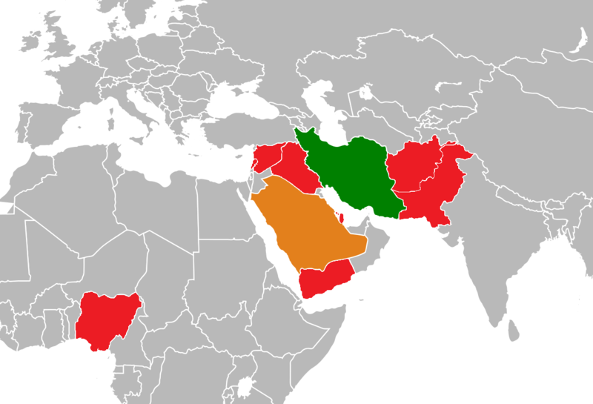

As a conclusion of this theory Israel, U.S and Saudi Arabia can act collectively to hinder or undermine the threat as they commonly perceived until it won’t pose a threat according to the Balance of threat theory.

NEOREALISM AND NEOCLASSICAL REALISM
Neorealism emerged in International Relation as a reformulation of Realism with ‘’Theory of International Politics’’ by Kenneth Waltz. The main difference from the classical Realism in foreign policy analysis is interests of states on accumulation of power not about human nature but the structure of international system (Therefore it is also called Structural Realism). The anarchy and insecurity are the driving power to the security dilemma (Arı 2013: 157). In this anarchic world, States should consider the power position in international system.
The relative power position of the states is the central explaining variable for the analysis of foreign policy. The state’s power and its foreign policy possibilities and restrictions are accepted the determining factor (Brummer, Oppermann 2013, 18). Realist foreign policy explanation consist of two important aspect to take into account: The first one is the relative capabilities of the state and the other is polarity of the system (idib).
The power of states can be explained by the material resources and other resources that plays a key role over the foreign policy. For material resources, the military and economic power of the state. How big the territories they have and how big the population are important (idib,19). In this case , U.S military power and its budget as we can see down is one of the explaining factor for the U.S foreign policy according to realism. 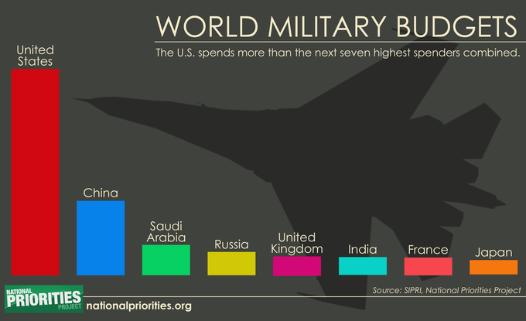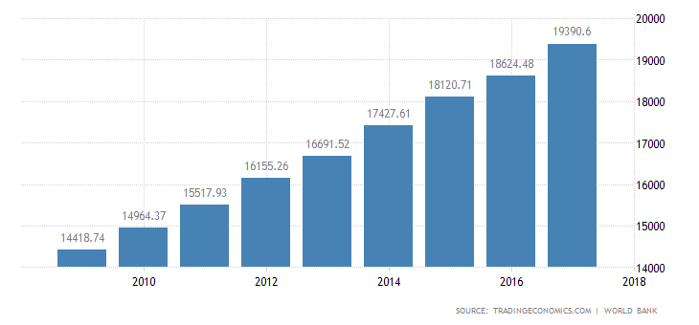

The second one is the polarity of the international system. The polarity of the system the other determining factor. It is about how many are there great powers within the international system. According to realism, bipolar system is safer than the other (Arı, 158). Because in bipolar world, there are only two big power and the other countries don’t have enough place to move in their foreign policy, in the sense that they are depended on the bloc leader. After the collapse of the Soviet Union, the bipolarity ended. That means the world is less consistent according to realism in polarity. According to the tables, it can be seen the U.S has a remarkable power with respect to material capabilities for realism. However, Iran nuclear deal was signed in 2015 and U.S withdrew in 2018. When U.S signed this deal the relative power position and the polarity of the system is the same. Therefore, neoclassical realism helps to explain U.S foreign policy with respect to this decision taking the domestic political incidence into account as intervening variable in international politics.
Neoclassical realism emerged as a reaction to the neorealism’s reductionism. They argue that the domestic policy are very influential on their foreign policy (Arı,173). They also criticized Structural realism because of ignoring the differences of democrat and republican parties in U.S and the role of Congress when they explain U.S and soviet relations (Arı, 175). It can be explain also the reason of withdrawal the different positions of political parties in U.S. The change of government is an intervening variable.

Finally, the other realist explanation for this case, It is offensive realism which is the theory variant in Neorealism. For the Offensive realist, relative power is not enough to be secure. Therefore, they argue the power maximization due to it cannot be known the other’s intention and material power. They also say the power maximization is the best way for state’s survival (Measheimer 2001: 29-36). Mearsheimer mentions the hegemon concept, that today, to be hegemon is quite hart because some great powers can be far away that makes the conquest hard and the other thing is nationalism (Mearsheimer 2014: 6-10). He mentioned the regional hegemon in his article ‘’Can China rise peaceful’’ that he accepts U.S as a regional hegemon and the regional hegemons aim should prevent the others desire to be hegemon (idib). He continues to giving examples from imperial japan, Kaiserreich, etc. (idib). Because those countries tried to be hegemon in their region but they didn’t succeeded in becoming so. In this case, Offensive realism can explain the withdrawal of U.S as The Iran’s power in the region lately. In these year, Iran’s growing power middle east, namely, victories in Syria, has an important influences on yemen, Iraq and others regions countries can create in the U.S, Iran’s hegemonic desires in middle east. As a response they withdrew and reimposed sanction according to the offensive realist explanation.

NEW LIBERALISM
The liberal approach explains that the foreign policy based on the domestic interest groups. The implementation power of the groups are determining factor. It is a bottom up approach and states are just transmission belt (Bummer, Oppermann 2013; 32). The Interest groups compete in domestic arena to influence the decision over foreign policy and those interest group can have transnational relation. When the decision making process begins, the state acts as honest broker, then aggregates interests and the implement in foreign policy (idib). In this case, the domestic lobbies and lobby firm which works with other countries can have an influence on withdraw from the deal. AIPAC and some other lobbies are against the deal with Iran from scratch (Palmer, Partinin 2015). On 8 may 2018 AIPAC broadcast a statement in support over the Trump’s decision.’’ the combination of a critically flawed 2015 nuclear deal with Iran and the international community’s inability so far to adequately address these shortcomings, we believe the administration’s decision today provides an important opportunity to address the shortcomings of the deal and to confront Iran’s escalating regional aggression’’ (AIPAC 2018). However, some other lobbies think differently. For instance, The Jewish Democratic council of America issued a statement criticizing Trump for his decision saying that there are also some limitation narrowly focusing on the nuclear program, to the exclusion of the other behavior. Nonetheless it prevents nuclear armed Iran. Moreover, this decision set us apart from our friends, as a result, that decision makes U.S isolated not Iran, said they (Tibon 2018).
Change of the government provided for accessibility to the decision-maker. For Arabic states and Israel. If we look at the other decision with respect to Middle East, it can be easily seen that Israel are getting more and more influential on decision-making in Iran. For example, Recognition of Jarusalem as a capital of U.S and after the P.M’s presentation the withdrawal decision taken by Trump (Cook 2018).

CONCLUSION
The withdrawal of U.S from the deal created uncertain situation in the world. One side deemed the as the best solution because it inhibits Iran from getting nuclear weapons. On the other hand, deal was criticized chiefly that focus narrowly and merely on the nuclear deal. As it is explained above by the help of the theories, the change of the decision-maker alter the perception of Iran, emerged the new priorities to solve this issue with Iran. Trump administration is developing its relations with Saudis and Israel. Iran’s policy in Middle-East seems contradicting with U.S generally in realism. For liberalism, the pro-Israel’s lobbies gained accessibility to the decision-maker and they could influence this decision according to their interests. However, withdrawal created division between European allies and U.S. Today the E.U and other signatory countries endeavor to save the deal.

REFERENCE LIST
AIPAC Statement on Iran Nuclear Deal Announcement (2018). Press Release https://www.aipac.org/learn/resources/aipac-publications/publication?pubpath=PolicyPolitics/Press/AIPAC%20Statements/2018/05/AIPAC%20Statement%20on%20Iran%20Nuclear%20Deal%20Announcement (last access 27.04.2019)
Arı, T. (2013). Uluslararası ilişkiler teorileri. 8.edt Bursa: MKM yayıncılık ltd. Şti .,pp 157-176
Behravesh, M. (2018). Commentary: Why Europe fears collapse of the Iran nuclear deal. Reuters https://www.reuters.com/article/us-behravesh-europe-commentary/commentary-why-europe-fears-collapse-of-the-iran-nuclear-deal-idUSKBN1OA2A9 (last access 24.04.2019)
Brummer, K. and Oppermann, K. (2014). Außenpolitikanalyse. Munich, Germany: Oldenburg Verlag, pp 15-40.
Borger, J. (2015). Iran nuclear deal: world powers reach historic agreement to lift sanctions. The Guardian, https://www.theguardian.com/world/2015/jul/14/iran-nuclear-programme-world-powers-historic-deal-lift-sanctions (last access 22.04.2019)
Byman, D. (2012). Iran’s support for terrorism in middle east. https://www.brookings.edu/wp-content/uploads/2016/06/25-iran-terrorism-byman-1.pdf (last access 25.04.2019)
Cook, J. (2018). Netanyahu’s Bombastic Iran Claims Found A Perfect Audience In Trump. Huffpost, https://www.huffpost.com/entry/netanyahu-trump-iran_n_5af1f26ae4b0c4f19327b5c7 (last access 27.04.2019)
Europa steht zum Iran-Abkommen. (2018) Bundesriegung https://www.bundesregierung.de/breg-de/aktuelles/europa-steht-zum-iran-abkommen-336648 (last access 22.04.2019)
Manson, R. (2017). Donald Trump to leave fate of Iran Nuclear deal in congress’s hands. Financial times, https://www.ft.com/content/a8854a58-afbe-11e7-aab9-abaa44b1e130 (Last access 22.04.2019)
Marcus, J. (2018). Trump re-imposes Iran Sanctions: Now what?. BBC, https://www.bbc.com/news/world-middle-east-46075179 (last access 23.04.2019)
Mearsheimer, J. (2014). Can China rise peacefully. The National Interest, pp 1-56 http://www.eastlaw.net/wp-content/uploads/2016/09/Can-China-Rise-Peacefully_-_-The-National-Interest.pdf (last access 26.04.2019)
Milani, M. (2013). Iran’s foreign policy: How to work with Iran’s pragmatic new president. Foreign Affairs. https://www.foreignaffairs.com/articles/iran/2013-06-25/rouhanis-foreign-policy (last access 24.04.2019)
Morello, C. (2018). U.S urges other nations to sanction Iran over the ballistic missiles. Washington post. https://www.washingtonpost.com/world/national-security/us-urges-other-nations-to-sanction-iran-over-ballistic-missiles/2018/04/28/eb7c8613-686d-4bff-b05a-7070f8611aea_story.html?utm_term=.526dea77f96c (last access 26.04.2019)
Nivet, B. (2018). Accord sur le nucléaire iranien : l’Union européenne malgré et contre l’allié américain. The Conversation. https://theconversation.com/accord-sur-le-nucleaire-iranien-lunion-europeenne-malgre-et-contre-lallie-americain-98736 (last access 23.04.2019)
Ostovar, A. (2018). The First Iranian-Saudi War Will Be an Even Fight. Foreign Policy. https://foreignpolicy.com/2018/05/07/the-first-saudi-iranian-war-will-be-an-even-fight/ (last access 26.04.2019)
Rascoe, A. (2018). Trump: U.S ‘’Will Withdraw from Iran nuclear deal. Vermont Public Radio, https://www.vpr.org/post/trump-us-will-withdraw-iran-nuclear-deal#stream/0 (last access 23.04.2019)
Sterio, M. (2016). President Obama’s Legacy: The Iran nuclear aggrement? Case western reserve journal of international law. Vol 48(1). Pp 69-82
Tibon, A. (2018). U.S. Jews Torn Over Trump's Exit From Iran Nuclear Deal. Haaretz https://www.haaretz.com/us-news/.premium-u-s-jews-torn-over-trump-s-exit-from-iran-nuclear-deal-1.6072385 (Last access 27.04.2019)
Traynor, I and Borger, J. (2009). Iran admits secret uranium enrichment plant. The guardian https://www.theguardian.com/world/2009/sep/25/iran-admits-uranium-plant (last access 23.04.2019)
U.S.-Russia Relations: “Reset” Fact Sheet. (2010). White House. https://obamawhitehouse.archives.gov/the-press-office/us-russia-relations-reset-fact-sheet (last access 23.04.2019)
Verification and monitoring in the Islamic Republic of Iran in light of United Nations Security Council resolution 2231. (2015). IAEA. https://www.iaea.org/sites/default/files/19/03/gov2019-10.pdf (last access 22.04.2019)
Witte, G. and Birnbaum, M. (2018). Europe says: It will stick with the Iran deal, defying a U.S demand. Washington post, https://www.washingtonpost.com/world/europe/europe-says-it-will-stick-with-the-iran-deal-defying-a-us-demand/2019/02/15/032923ee-2fac-11e9-8781-763619f12cb4_story.html?noredirect=on&utm_term=.28c18ef329e0 (last access 24.04.2019)

https://en.wikipedia.org/wiki/Iran%E2%80%93Saudi_Arabia_proxy_conflict#/media/File:Iran%E2%80%93Saudi_Arabia_proxy_conflict.png
https://tr.tradingeconomics.com/united-states/gdp
https://www.nationalpriorities.org/campaigns/us-military-spending-vs-world/

